*Step 1: Download the helm binary*

curl -fsSL -o helm.tar.gz https://get.helm.sh/helm-v3.4.1-linux-amd64.tar.gz

*Step 2 : unzip the helm binary*

tar -xzf helm.tar.gz

*Step 3 : list the directories*

ls

*Step 4 : check the helm version installed*

helm version

*Step 5 : cd to /linux-amd64/*

cd linux-amd64/

*Step 6 : list the helm binary*

helm ls

*Step 7 : move helm binary to /usr/bin*

mv helm /usr/bin

*Step 8 : verify helm installed*

helm version

*Step 9 : check helm repos*

helm repo list

*Step 10 : add stable repo*

helm repo add stable https://charts.helm.sh/stable

*Step 11 : check hel repo list again*

helm repo list

*Step 12 : update the helm client with the repo for update of new charts*

helm repo update

*Step 13 : search chart wordpress*

helm search repo wordpress

*Step 14 : install the wordpress chart form stable repo*

*helm fetch stable/wordpress*

*tar -xvf wordpress-9.0.3.tgz*

*vim wordpress/values.yaml*

*Line 325 ( change to false from true)*

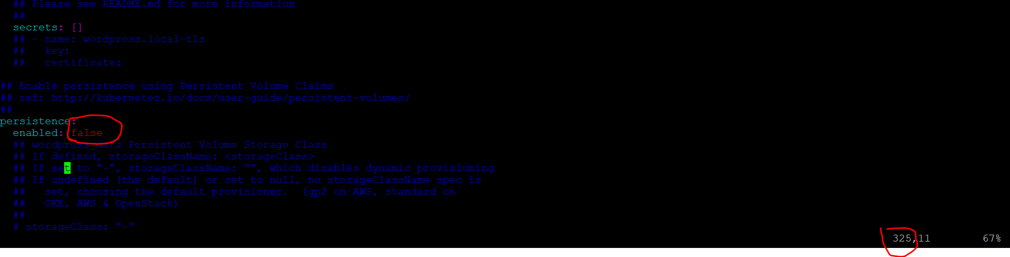

*Line 371 ( change to false from true)*

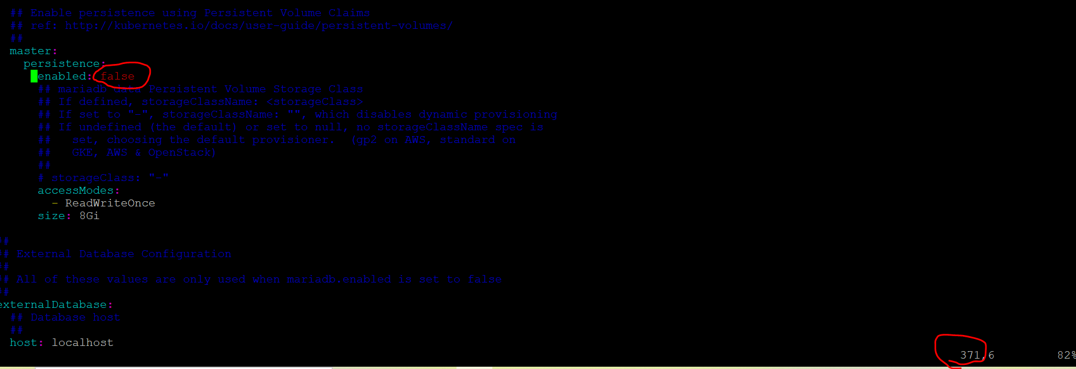

***Deploy the chart***

helm install demowp stable/wordpress -f wordpress/values.yaml

*Instructions to access app ( use highlighted commands from your outputs when u deploy)*

*To access your WordPress site from outside the cluster follow the steps below:*

*1. Get the WordPress URL by running these commands:*

*NOTE: It may take a few minutes for the LoadBalancer IP to be available.*

*Watch the status with: 'kubectl get svc --namespace default -w demowp-wordpress'*



*To access app : use your minion node publicp:port number in above output*

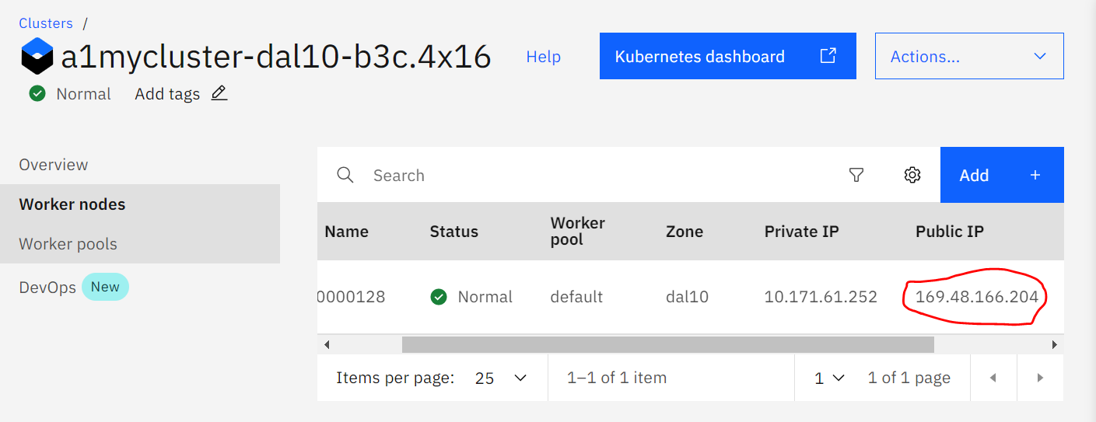

*Check if app running*

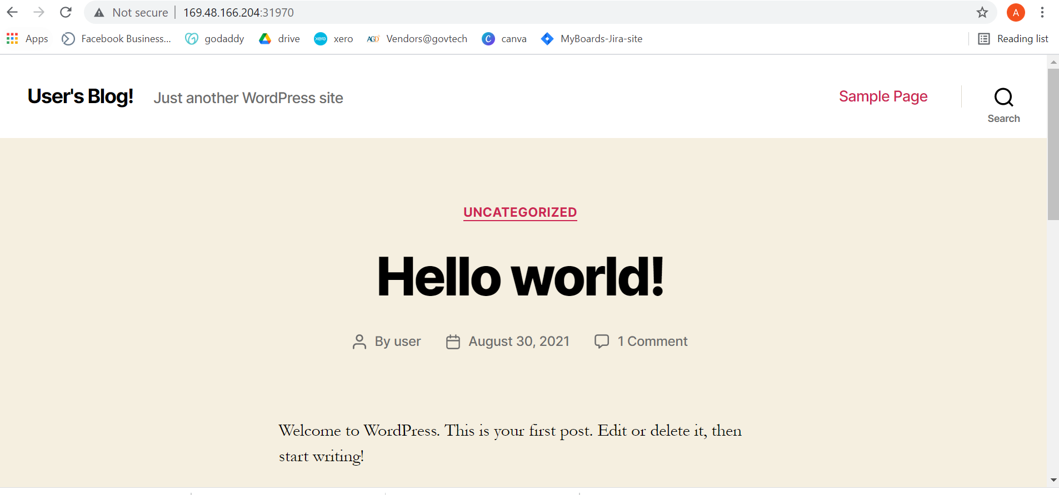

*export SERVICE_IP=$(kubectl get svc --namespace default demowp-wordpress --template "{{ range (index .status.loadBalancer.ingress 0) }}{{.}}{{ end }}")*

*echo "WordPress URL: http://$SERVICE_IP/"*

*echo "WordPress Admin URL: http://$SERVICE_IP/admin"*

*2. Open a browser and access WordPress using the obtained URL.*

*3. Login with the following credentials below to see your blog:*

*echo Username: user*

*echo Password: $(kubectl get secret --namespace default demowp-wordpress -o jsonpath="{.data.wordpress-password}" | base64 --decode)*

*Step 16 : Check what happened behind the scenes*

kubectl get svc

kubectl get pods

kubectl get deploy

*Step 15 : list the chart*

helm ls

*Step 16 : Delete the chart*

helm delete demowp